**PIZZA SALES SQL QUERIES**

# A.KPI

1.Total Revenue



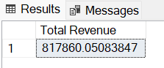

2.Average Order Value



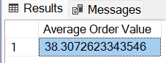

3.Total Pizzas Sold



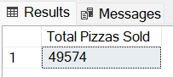

4.Total Orders



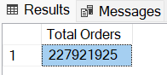

5.

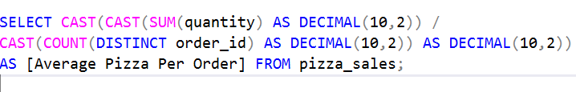

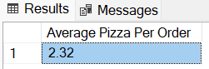

# B.Daily Trend For Orders

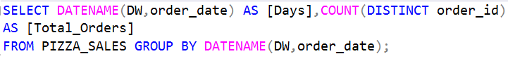

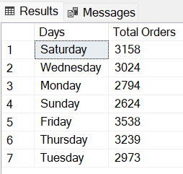

# C.Monthly Trend For Orders



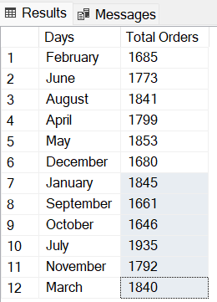

# D.% Sales by Pizza Category

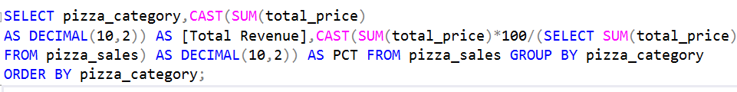

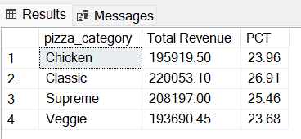

# E.% Sales by Pizza Size

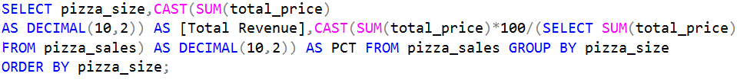

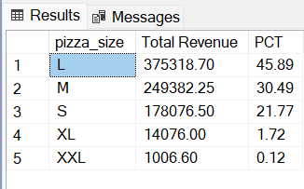

# F. Total Pizzas Sold By Pizza Category



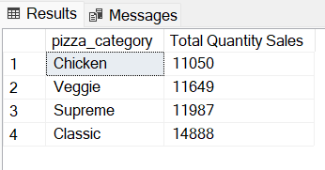

# G.Top 5 Pizzas By Revenue



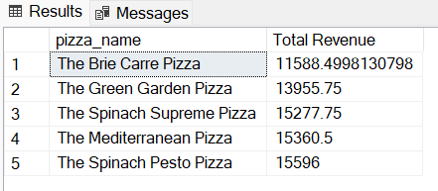

# H.Bottom 5 Pizzas By Revenue



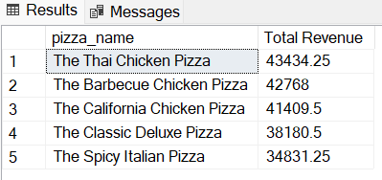

# I.Top 5 Pizzas by Quantity



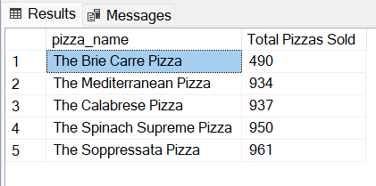

# J.Bottom 5 Pizzas by Quantity



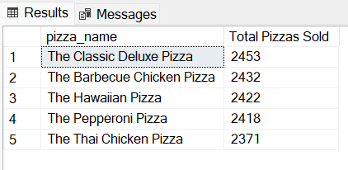

# K.Top 5 Pizzas by Total Orders



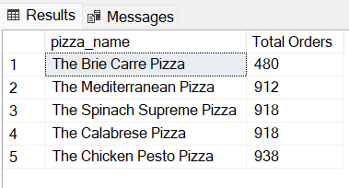

# L.Bottom 5 Pizzas by Total Orders



